

**EAST WEST UNIVERSITY**

**Project Report**

**Course Code : CSE405**

**Course Title : Computer Networks**

**Section : 02**

**Submitted By**

Name : Adnan Saif Dipto

ID : 2018-1-60-157

**Submitted To**

Dr. Anisur Rahman

Associate Professor

Department of CSE,

East West University

**Date of submission : 14-05-2022**

**Title:** Design a full-fledged network for an organization with multiple subnets.

**Introduction:** An enterprise like East West University, namely University of Professionals, owns a large number of computers with a complex network infrastructure using both wired and wireless access. The task is to develop a full-fledged network for the organization using multiple subnets.

**Tools:** For this project, I will be using CISCO Packet Tracer Version 7.2.1. Using this, I will design the whole physical network for the organization.

**Methodology:** I will be using switching/routing mechanism for the project. I will also incorporate different subnets. Now, the first thing to do is creating a router configuration as given in the handout.

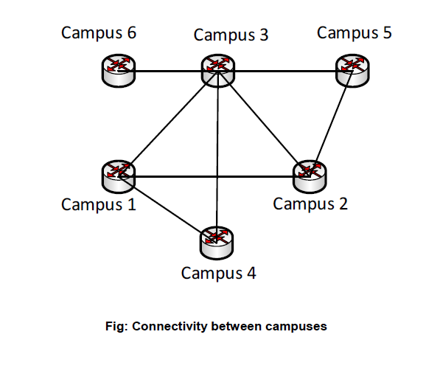

Now, for simplicity, I will put three wired PC’s and a wireless laptop. An access point will be there for wireless connection. All the IP will be given using a single a DHCP server. For accessing the webserver, a DNS server will also be incorporated. All the connection will be given using straight-through cable. This will be the general representation of all the routers. A picture of router 1 is shown below-

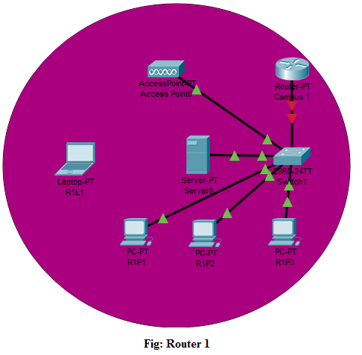

After all the connecting all the devices with straight through cable, I will introduce the IP address to the servers. For server 1, I will create DHCP and DNS service manually and give IP: 192.168.10.100 with gateway address: 192.168.10.254. All the IP address of other devices will be given through the DHCP server. The access point will give wireless access to the Laptop and the IP will also be given through the DHCP. As DNS service is enabled, I will give the DNS name: [www.professionals.edu](http://www.professionals.edu), which will be accessible for the IP 192.168.10.100.

The same process will be applied for all the other servers. IP for other servers are given below-

Server 2 IP: 157.122.20.100

Server 3 IP: 18.60.30.100

Server 4 IP: 18.60.40.100

Server 5 IP: 157.122.50.100

Server 6 IP: 192.168.60.100

Here IP of servers 1 and 6 are of Class C, servers 2 and 5 are of class B and servers 3 and 4 are of Class A.

Now, after connecting and setting up the IP for the wired devices, I will add a wireless adaptor to the Laptops. In the packet tracer, the adaptor is “WPC300N”. Through this adaptor, the laptop will have wireless access. The access point will have connection to the server and through the adaptor; the laptop will connect the server and get an IP address.

Now for the last part, we will connect the routers as given in the handout. The first work here will be to configure the routers and the switches. For that I will write “CLI Command”. The Code for router 1 is given as an example-

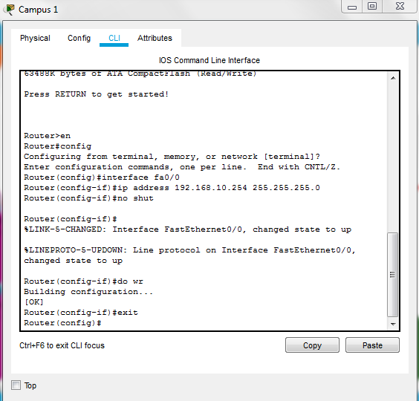

Here, as I am configuring only the switches, that are why, I am creating connection to the Fast Ethernet port. The other routers will be configures in the same way.

Now we will connect the routers with serial DCE connectors. Here we will use default clock rate 64000 for CISCO packet tracer.

After connection the routers will look like –

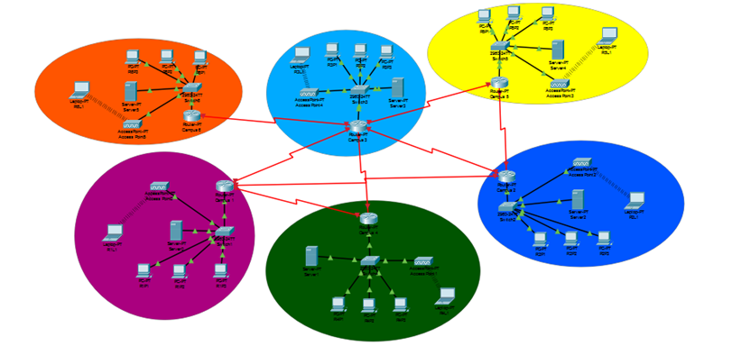

For testing purpose I will check the browser of a PC to see the website of the University of the Professionals.

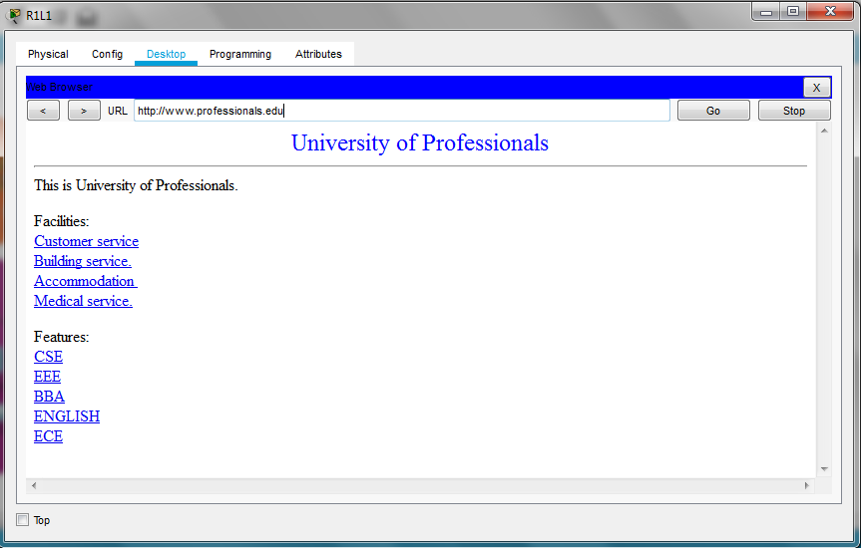

**Conclusion:**

In this experiment I have designed network structure for the University of the Professionals. Using packet tracer all the simulation was conducted.